Supplementary Information – Sources of Variation in Cell-Type RNA-Seq Profiles

This document contains supplementary information for “Sources of Variation in Cell-Type RNA-Seq Profiles”.

Pairwise Sample Comparison
The Log Fold-Change Standard Deviation (LFCSD) metric is used to compare the transcriptomes between two samples. The metric is the standard deviation of the log2 fold change of all genes. Fig. S1 shows the histograms over the log2 fold change over all genes (pseudo-TPM >= 1) for four different pairs of samples. The differences between samples of different cell type and different lab are the highest, followed by differences in subcellular type. The sample where no factor is different gives the least variation in log fold change. All pairs yield an approximate bell shape, motivating the fairness of the standard deviation of the fold changes as a metric of sample dissimilarity.
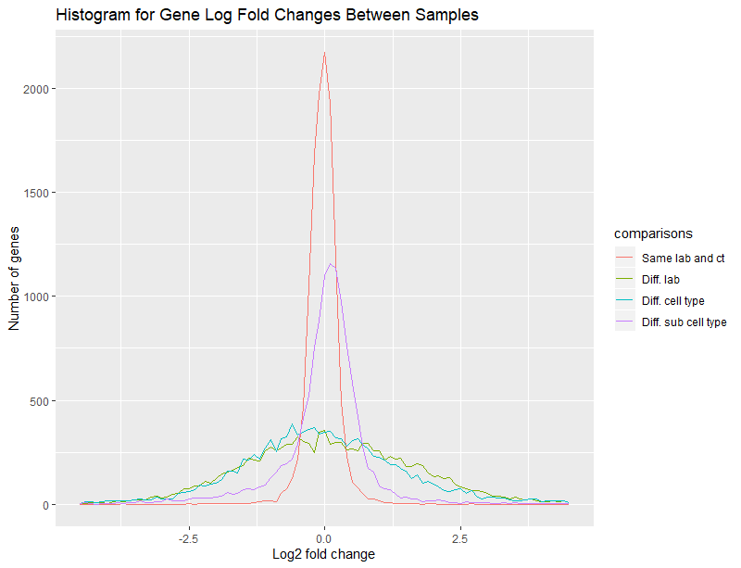
Fig. S1 Histogram over log₂ fold change over all genes between pairs of samples having different cell type (ct), cell sub type, and laboratory(lab), compared to samples where these factors are not present.
Pearson correlation on log-transformed data is an alternative to the LFCSD metric for pairwise comparison of samples. The downside of Pearson correlation is that it doesn’t directly compare the samples. The sample scaling, which is done as part of the normalization, is not taken into account. The Pearson correlation method in general gives similar results but assigns slightly less importance to technical factors.
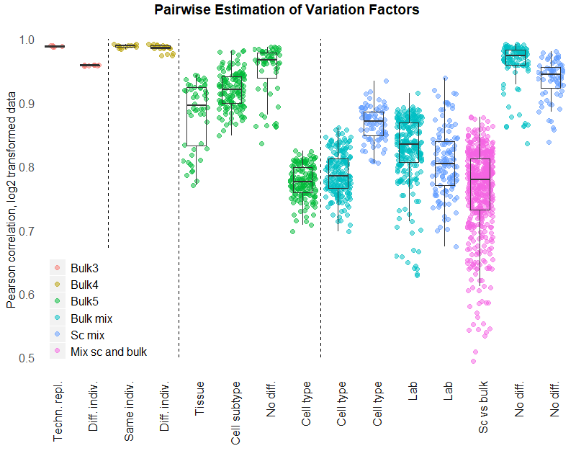
Fig. S2 Pairwise comparison of samples using the Pearson correlation, as an alternative to what is shown in the main text.

The Dependency between UMICF and Gene Expression
The UMI copy fraction covariate used in the main text is correlated with gene expression, likely due to sampling effects on lowly expressed genes (Fig. S3). However, there are also many genes with high expression and low UMICF, ruling out the possibility that this effect has its origin in sampling effects only.
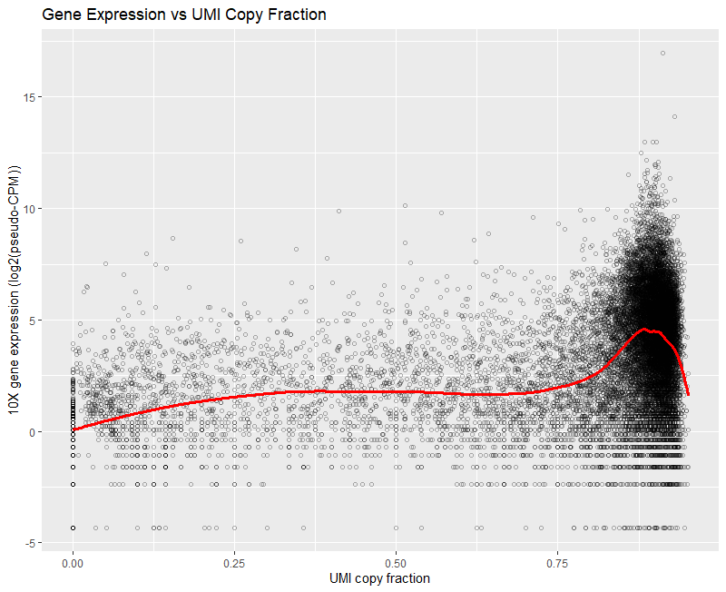
Fig. S3 Average gene expression per gene vs the UMICF covariate. The gene expression is from Cortex1, while UMICF is calculated from Cortex2, both from the EVAL dataset, 10x single-cell data, normalized using TMM. Only genes with 5 molecules or more in Cortex2 is shown.
Since the UMICF variable is correlated with gene expression, we investigated if that could explain the improvement in correlation between single-cell and bulk RNA-Seq from regressing out the UMICF variable. We reasoned that systematic differences in gene expression over the gene expression range between single-cell and bulk could indirectly be regressed out when regressing out UMICF and consequently make the sample data more similar. If this would be the case, regressing out UMICF could be replaced by quantile normalization, which effectively removes any such differences. To test this, we performed the same analysis as in the main text (i.e. comparing 10x single-cell data with bulk from the EVAL dataset) but using quantile normalization instead of TMM (Fig. S4). Compared to the case for TMM normalization, regressing out the UMICF covariate is slightly less effective, but the results are still similar. This suggests that systematic differences in gene expression over the gene expression range between single-cell and bulk can only explain a small part of the improvement in correlation of gene expression between single-cell and bulk resulting from regressing out the UMICF covariate.
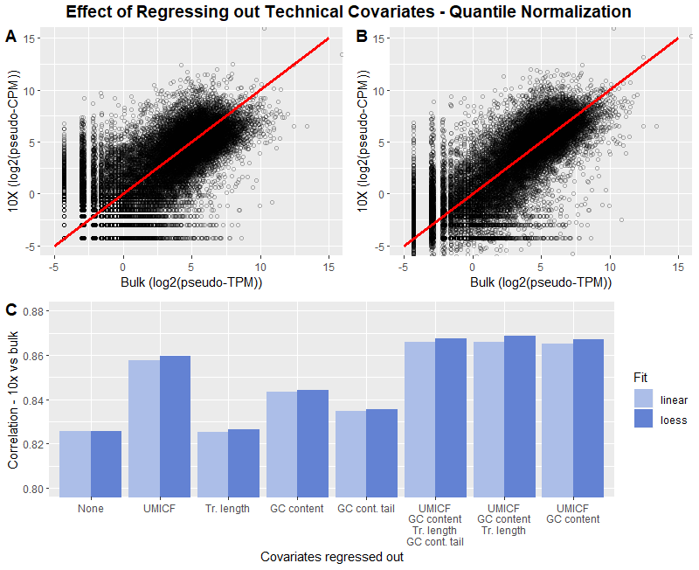
Fig. S4 Gene expression for cortex 1 from the EVAL dataset plotted as 10x vs bulk. The red line represents a perfect correlation. B. Gene expression for cortex 1 from the EVAL dataset after regressing out the differences in UMICF and GC content between 10x and bulk using a loess fit, which improves the correlation. C. Average Pearson correlation coefficient between 10x data and bulk in log scale after regressing out technical covariates (UMI copy fraction, transcript length, GC content and GC content tail), using linear or loess regression. The correlation shown is the average of the correlations from cortex 1 and 2 of the EVAL dataset, using quantile normalization.

Software Verification/Validation
To ensure the quality of our analyses, we verified and validated the code using a combination of test cases, reasoning around expected outcome of a function and code review. The details of this activity are available in the verification matrix that is available together with the code at: doi.org/10.5281/zenodo.3631488.

